Driver Management System

|  |  |  |
| --- | --- | --- |
| Name | Driver Management System | |
| Summary | Assign and manage drivers to the vehicles which are rented by a renter. | |
| Priority | 04 | |
| Preconditions | Driver should register to the system. | |
| Postconditions | Assigned driver will drive the trip. | |
| Primary Actor(s) | Renter, Vehicle Owner , Driver | |
| Main Scenario | **Step** | **Action** |
| 01 | Driver registers in the driver management system. |
| 02 | Owner checks for the reservations. |
| 03 | Owner assigns a driver to the trip. |
| 04 | Driver checks the date, no. of days and the location that the trip is planned. |
| 05 | Driver sends the status whether the date was free or busy. |
| 06 | Owner checks the driver availability status. |
| 07 | Drivers can handover their license details to the system. |
| 08 | Driver manager checks and separate the light weighted and heavy weighted license holders. |
| 09 | Driver manager can check the payment details of the drivers. |
| 10 | Drivers can present their problems to the system. |
| 11 | Driver manager notices the problems and take necessary steps. |
| 12 | Renters can send feedback about the driver. |
| 13 | Driver manager read the feedback. |
| 14 | Customer can rate drivers. |
| Extensions | **Step** | **Action** |
|  | 1.a | If credentials are wrong driver must re-enter the credentials. |
|  | 6.a | If driver not available owner tries to assign alternative driver |
|  | 8.a | Drivers can only drive the vehicles according to their license category. |
|  | 13.a | If there are complaints, the driver manager will forward that to the particular driver. |

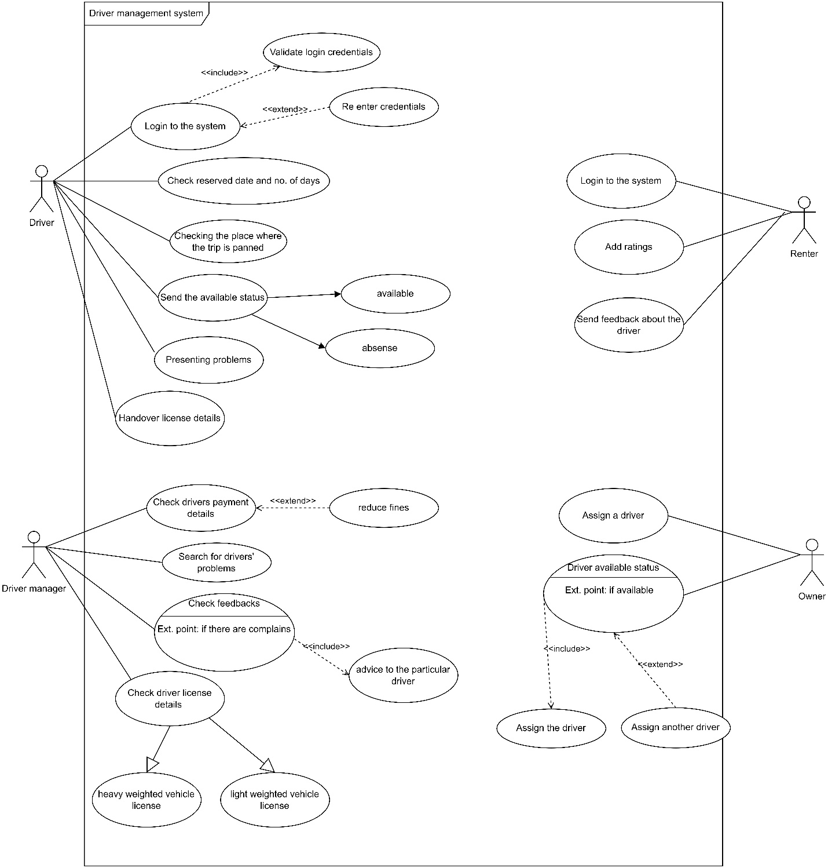

**A Driver Manager’s story,**

* As a driver manager, I want to handle the driver related activities. I want the ability as soon as possible. So, we can provide a faster and quality service for the customer.
* As a driver manager, I want the ability to manage user profiles. So, I can add or remove new drivers.
* As a driver manager, I would like to know the customer feedback and if there are any mistakes or faults of drivers, I may ask them to correct the mistakes.

**Functional requirements**

* **Allow drivers to register with the platform.**
* **Should be able to create and update their profiles.**
* **Provide a user-friendly interface for drivers to browse the available vehicles.**
* **Implement a feature to verify the authentication of their license.**
* **Send notifications for drivers for reservation confirmations, upcoming bookings etc.**

**Nonfunctional requirements**

* Reliability, availability, scalability, user-friendly, usability, and security
* The system should be available 24/7 with minimal downtime.
* The system should be easy to use for all types of users.
* The system should ensure the privacy and security of user data.

**Technical requirements**

* The system should be built using a client-server architecture.
* The system should be compatible with different web browsers and devices.
* The system should be hosted on a secure and reliable web server.
* The programming languages - java script
* Frameworks - React
* Databases- MongoDB